Week 2 cyber security

Task 1:-
1. LAN — Local Area Network:- A LAN is a network that connects computers and other devices within a small geographical area, such as a room, home, school, office, or computer laboratory.
The computers connected together in a school computer laboratory form a LAN.
- Homes
- Schools and colleges
- Offices
- Small businesses
2. MAN — Metropolitan Area Network:- A MAN is a network that connects multiple LANs across a larger area, usually covering a city or a large town.
A university may connect its different campuses located across a city using a MAN.

- Universities with multiple campuses
- Government organizations
- City-wide networks

3. WAN — Wide Area Network:- A WAN connects networks over a very large geographical area, such as different cities, countries, or continents.
The Internet is the largest example of a WAN because it connects networks around the world.
- Internet
- International companies
- Banks
- Cloud services
- Organizations with offices in different countries

4. PAN — Personal Area Network:- A PAN is a very small network used to connect personal devices around an individual, usually within a few metres.
Connecting a smartphone to wireless earbuds using Bluetooth.
- Smartphones
- Smartwatches
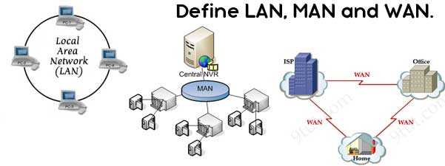

Task 2:-
An IP (Internet Protocol) address is a numerical address assigned to a device on a network. It helps identify the device and allows data to be delivered to the correct destination.
Example: 192.168.1.10
An IP address can change depending on the network and how the device receives its address.

IPv4 stands for Internet Protocol version 4.
It uses a 32-bit address and is normally written as four numbers separated by dots.
Example: 192.168.1.25
Each number can range from 0 to 255.

A private IP address is used inside a local network, such as a home, school, or office network. It is not directly reachable from the public Internet.
Common private IPv4 ranges include:
10.0.0.0 – 10.255.255.255
172.16.0.0 – 172.31.255.255
192.168.0.0 – 192.168.255.255
Example: 192.168.1.5

A public IP address is an address used to identify a network or device on the public Internet. It is normally assigned by an Internet Service Provider (ISP).

MAC stands for Media Access Control.
A MAC address is a hardware/network-interface identifier associated with a network interface. It is normally represented as six groups of hexadecimal characters.
Example: A4:5E:60:12:AB:9A
It is primarily used for communication within a local network.

Difference Between IP Address and MAC Address
Feature | IP Address | MAC Address
Full form | Internet Protocol Address | Media Access Control Address
Purpose | Identifies a device/network location for IP communication | Identifies a network interface on the local network
Type | Logical/network-layer address | Link-layer/hardware identifier
Example | 192.168.1.17 | A4:5E:60:12:AB:9A
Can change? | Often can change | Usually associated with the network interface, though devices can use randomized/spoofed MAC addresses
Used mainly for | Routing data between networks | Local network communication

Task 3:-
1. Router
A router connects different networks and forwards data packets between them. In a home network, it commonly connects the local network to the Internet.
Homes, offices, schools, businesses, and data networks.
example:
A home Wi-Fi router supplied by an Internet service provider.

2. Switch
A switch connects multiple wired devices within a local network and forwards Ethernet frames to the appropriate device.
Offices, schools, computer laboratories, and data centers.
example:
A 24-port Ethernet switch connecting computers and printers in an office.

3. Modem
A modem provides the connection between a local network and an ISP's access network by converting/signaling data according to the access technology being used.
Homes and offices that receive Internet service through technologies such as cable or DSL.
example:
A cable modem used to connect a home network to a cable Internet service.

4. Access Point:-An access point provides wireless network access to devices such as smartphones, laptops, and tablets.
Homes, offices, schools, hotels, airports, and public places.
example:
A ceiling-mounted Wi-Fi access point in an office.
5. Firewall
A firewall monitors and controls network traffic according to security rules. It can help block unauthorized or unwanted connections.
Computers, home routers, offices, organizations, and data centers.
example:
A firewall built into a home router that blocks unwanted incoming connections.

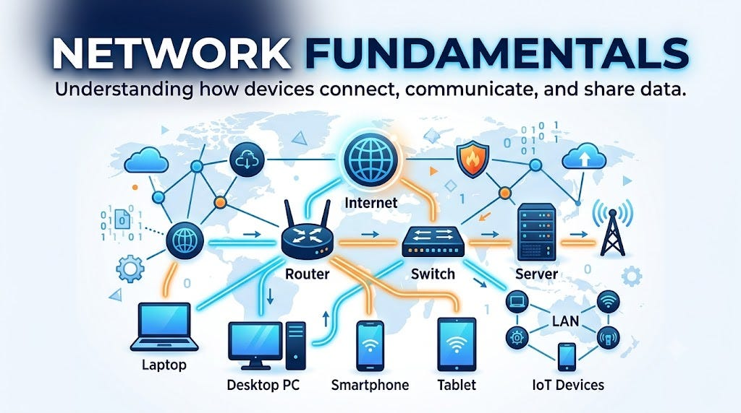

Task 4:-
Protocol | Full Form | Purpose | Real-World Example
HTTP | Hypertext Transfer Protocol | Transfers web resources between a browser and web server | Loading a webpage
HTTPS | Hypertext Transfer Protocol Secure | Provides HTTP communication protected using TLS encryption | Online banking website
DNS | Domain Name System | Converts domain names into IP addresses | Finding the IP address for example.com
TCP | Transmission Control Protocol | Provides reliable, ordered delivery of data | Downloading a file
UDP | User Datagram Protocol | Provides fast, connectionless transport without guaranteeing delivery | Live video or online gaming
HTTP
HTTP allows web browsers and web servers to communicate and exchange web resources.
Example:
A browser requests a webpage from a web server using HTTP.
HTTPS
HTTPS is HTTP protected with TLS (Transport Layer Security). It helps protect data from being read or modified while it travels between the browser and server.
Example:
Entering information on an online shopping website.
DNS
DNS translates human-readable domain names into IP addresses that computers can use for network communication.

Example:
www.example.com
↓
DNS lookup
↓
IP address
TCP
TCP establishes a connection and provides reliable, ordered delivery of data. If appropriate, lost data can be retransmitted.
Example:
Downloading a document where accurate delivery is important.
UDP
UDP is a connectionless transport protocol with lower overhead than TCP. It does not guarantee delivery or ordering.
Example:
Real-time applications such as online gaming and some live audio/video traffic.

Task 5:-
When you type:
www.example.com
into a browser, several steps occur.
Step 1 — User
The user enters:
www.example.com
into the browser's address bar.
Step 2 — Browser
The browser determines that it needs to access the website and begins the process of locating the server.
Step 3 — DNS
The domain name needs to be translated into an IP address.
The computer sends a DNS query to a DNS resolver.
www.example.com
↓
DNS Resolver
↓
IP Address
Step 4 — Router
The computer sends network traffic toward its default gateway, usually the local router.
The router forwards the traffic toward the Internet.
Step 5 — Internet
The data travels through multiple networks and routers across the Internet toward the destination server.
Step 6 — Server
The destination web server receives the request and processes it.
Step 7 — Response
The server sends the requested webpage/resources back through the network.
The browser receives the response and displays the webpage.

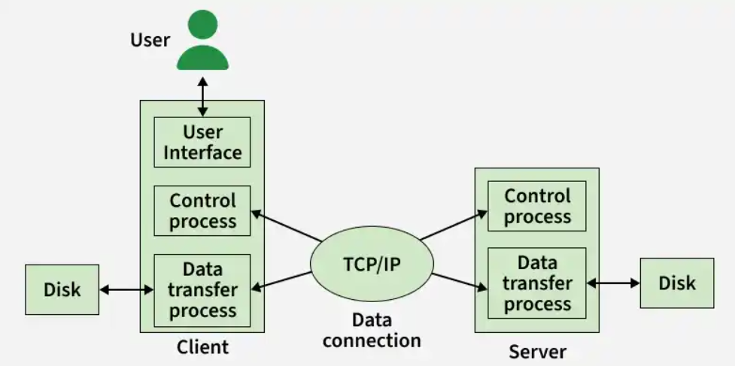

Task 6:-
10 Basic Practices for Securing a Home Wi-Fi Network
- Use a strong and unique Wi-Fi password.
- Change the default administrator password of the router.
- Keep the router's firmware updated.
- Use WPA2 or WPA3 security instead of outdated security methods.
- Avoid connecting to unknown or suspicious Wi-Fi networks.
- Disable WPS if it is not needed.
- Change the router's default network name if appropriate.
- Use a guest network for visitors and untrusted devices.
- Disable remote administration unless it is genuinely required.
- Regularly check the router for unknown connected devices.

Explain Any 3 Practices in Detail
1. Use a Strong Wi-Fi Password
A weak password can be guessed or attacked more easily. A strong password should be long and difficult to guess. It should avoid easily available personal information such as names or birthdays.
Example:
Weak: password123
Stronger: BlueRiver!47Cloud#92
A unique password also prevents a password reused on another service from compromising the Wi-Fi network.

2. Keep Router Firmware Updated
Router manufacturers release firmware updates to fix security vulnerabilities, improve performance, and sometimes add new features.
Therefore, users should regularly check whether their router has a newer firmware version and install updates from the manufacturer's official source.

3. Use WPA2 or WPA3
WPA2 and WPA3 are wireless security standards designed to protect Wi-Fi communications. WPA3 provides newer security improvements where supported.
Users should avoid obsolete security methods such as WEP, which is no longer considered secure.

